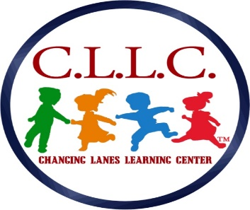
Childcare Center
119 Chester Pike
Norwood, PA. 19074
School # 610-237-0446/Fax # 610-237-1909
E-mail: Changinglanes@comcast.net
Shelter In Place
In the event of an emergency and the need to shelter in place, the children and staff at Changing Lanes learning Center will relocate to one of two designated spaces in either the fireplace room or Infant room. We will be away from any windows and place ourselves down below close to the floor.
Parents will be notified as to their safe whereabouts.
3270.27 Emergency plan.
(a) The facility shall have an emergency plan that provides for:
(1) Shelter of children during an emergency including shelter in place at the facility and shelter at location away from the facility premises.
(2) Evacuation of children from the facility building and evacuation of children to a location away from the facility premises. The evacuation routes and evacuation plan to exit the building may be the same as those required by 3270.94(f) and (g) (relating to fire drills.
(3) A method for facility person to contact parents as soon as reasonably possible when an emergency arises.
(4) A method for facility persons to inform parents that the emergency has ended and to provide instruction as to how parents can safely be reunited with their children.

Dr. Naomi Pereira-Lane/Owner
Marie-Chantalle Louis/Director of Operations
Kerin Cashin/Director of Finances

